**Progression of coronary artery calcium over twelve years in the CACTI study**

Background

The purpose of this analysis is to determine which factors predict changes in coronary artery calcium over time.

Methods

Visits after any revascularization procedures were excluded from analysis. Coronary artery calcium (CAC) volume was square root transformed prior to analysis. Progression of CAC was defined as an increase in square root-transformed CAC volume by more than 2.5 units between visits, so that each visit after baseline had a value of CAC progression assigned to it. An overall CAC progression variable was defined for each participant as any visit with progression since the previous visit.

We used group-based trajectory modeling to examine the variability in changes in CAC over time, to identify groups of participants with similar trajectories, and to estimate the probability of group membership for each participant. Both the square root-transformed CAC volume and CAC progression were used as outcomes for the group-based trajectory models. A censored normal model was fit to CAC volume, and a logistic model was fit to CAC progression. For each outcome, we compared a series of models using AIC to select the best model. The series of models included either 3, 2, or 1 groups, either linear, quadratic, or cubic trajectories, and with and without inclusion of baseline age as a risk factor. The group-based trajectory modeling was done within the T1D and non-T1D groups separately, and then with all participants combined. We used SAS PROC TRAJ to implement the group-based trajectory modeling.

Once we identified the final model for CAC volume, we used the chi-square test and the kappa statistic to examine the agreement of the trajectory groups with progression defined as an increase of more than 2.5 units between any two consecutive visits.

We used logistic regression to examine the association of baseline covariates with group membership. A base model included only diabetes status, sex, and the diabetes*sex interaction. The full logistic model included these terms plus the following variables:

* Age
* years of school
* BMI
* waist circumference
* LDL, HDL, triglycerides
* systolic BP, diastolic BP
* estimated insulin sensitivity (equation 2)
* albumin:creatinine ratio (AC), estimated creatinine clearance (CKD-Epi)
* adiponectin
* amount of moderate and vigorous activity by physical activity questionnaire
* non-Hispanic white race/ethnicity
* smoking status
* use of hypertension medications, use of statin medications, and use of anti-depressive medications.

We used stepwise logistic regression and lasso regression to identify which of these variables best predicts group membership. For the stepwise model selection, the terms sex, diabetes, and sex*diabetes were forced into the model. This was not the case for the lasso model selection since there is no available option for that in SAS.

SAS version 9.4 was used for all analyses.

Results

A total of participants, with diabetes and without diabetes, were included in this analysis.

The groups and trajectories of CAC volume and progression identified by the group-based trajectory modeling were similar for the analyses done within the T1D and non-T1D groups, and with all participants combined, so the remainder of the results described in this report are for all participants combined.

For the CAC volume outcome, the model with the lowest AIC had two groups with cubic trajectories in each group and no adjustment for baseline age (Figure 1). For CAC progression, the model with the lowest AIC had only one group (Figure 2). Because there only one group was identified for the CAC progression outcome, the final model selected for further analysis was the model using CAC volume as the outcome.

Descriptive statistics for the two trajectory groups for the CAC volume outcome are in Table 1.

Table 2 is a cross-tabulation of trajectory group membership with the original study definition of CAC progression. Of those without CAC progression by the original study definition, 1.3% were in group 2 and 98.7% were in group 1. Of those with CAC progression by the original study definition, 21.2% were in group 2 and 78.8% were in group 1. So it appears as though there are some CACTI participants who would have been defined as having CAC progression by the original definition who are included in group 1, with slow increases in CAC. However, most of the participants who would be classified as progressors were included in group 2, with more rapid increases in CAC. The p-value for the association between CAC progression and group membership was <0.0001. The kappa statistic was 0.2306, or fair agreement.

In the base model with membership in group 2 as the outcome, there was a significant interaction of sex and diabetes (Table 3a). Estimates of the odds ratios are in Table 3b.

In the fully adjusted model, the interaction of sex and diabetes was still highly significant (p<0.0001). Other significant covariates were age, BMI, LDL, hypertension medications, and statin medications (Table 4a). Odds ratio estimates for the interaction of sex and diabetes are in Table 4b. Odds ratio estimates for other covariates are in Table 4c.

The final model obtained by stepwise selection included the following effects: sex, diabetes, sex*diabetes, age, BMI, LDL, albumnin:creatinine, hypertension medications and statin medications (Table 5a). Odds ratio estimates for the interaction of sex and diabetes are in Table 5b. Odds ratio estimates for other covariates are in Table 5c.

The final model obtained by LASSO selection included age, BMI, waist circumference, LDL, diastolic BP, estimated insulin sensitivity, albumin:creatinine, CKD-epi score, adiponectin, moderate activity, and vigorous activity. These effects were entered into a logistic regression model with sex, diabetes, and sex*diabetes; results are in Table 6a. Odds ratio estimates for the interaction of sex and diabetes are in Table 6b. Odds ratio estimates for other covariates are in Table 6c.

Figure 1. Results of group-based trajectory models for CAC volume outcome, without adjustment for baseline age.

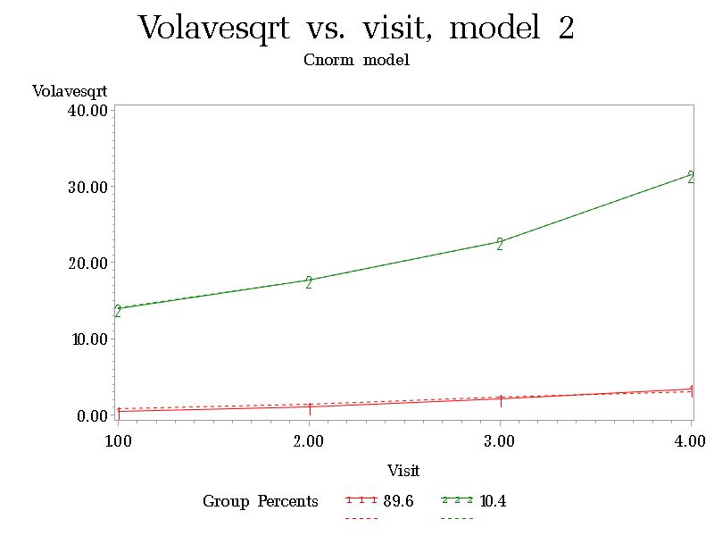

Figure 2. Results of group-based trajectory models for CAC progression outcome, with adjustment for baseline age.

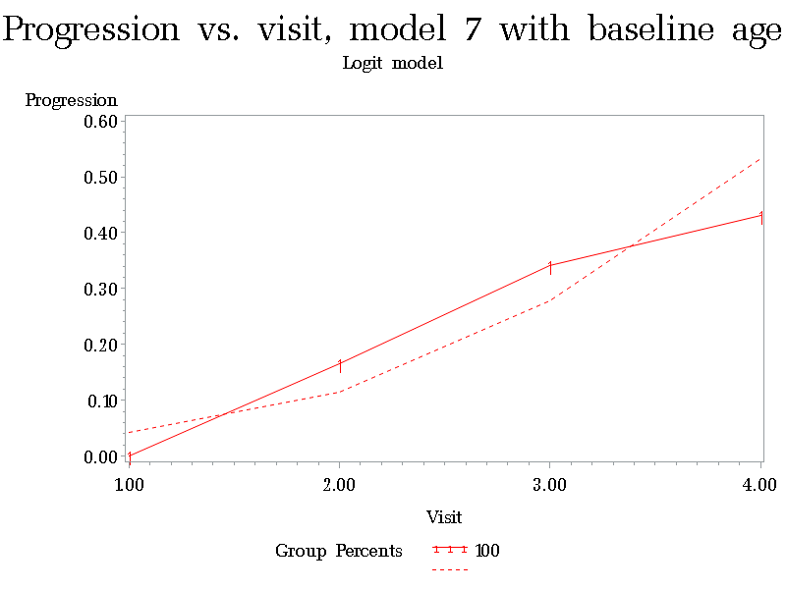

Table 1. Descriptive statistics for the two trajectory groups for the CAC volume outcome.

|  |  | *Group 1* | *Group 2* | *Unadjusted P-value* |
| --- | --- | --- | --- | --- |
| Age group | 12-29 | 304(23.81) | 1( 0.72) | <.001 |
|  | 30-39 | 473(37.04) | 14(10.07) |  |
|  | 40-49 | 375(29.37) | 67(48.20) |  |
|  | 50-59 | 125( 9.79) | 57(41.01) |  |
| Sex | Male | 588(46.05) | 92(66.19) | <.001 |
|  | Female | 689(53.95) | 47(33.81) |  |
| Non-Hispanic White | No | 185(14.59) | 9( 6.52) | 0.009 |
|  | Yes | 1083(85.41) | 129(93.48) |  |
| Diabetes status | Control | 723(56.62) | 41(29.50) | <.001 |
|  | T1D | 554(43.38) | 98(70.50) |  |
| Smoking status | Current | 124( 9.93) | 16(11.51) | 0.111 |
|  | Former | 264(21.14) | 39(28.06) |  |
|  | Never | 861(68.94) | 84(60.43) |  |
| ACEi use | No | 1105(86.53) | 91(65.47) | <.001 |
|  | Yes | 172(13.47) | 48(34.53) |  |
| ARB use | No | 1255(98.28) | 129(92.81) | <.001 |
|  | Yes | 22( 1.72) | 10( 7.19) |  |
| On hypertension meds | No | 1044(81.75) | 71(51.08) | <.001 |
|  | Yes | 233(18.25) | 68(48.92) |  |
| Lipid med use | No | 1169(91.54) | 93(66.91) | <.001 |
|  | Yes | 108( 8.46) | 46(33.09) |  |
| Statin use | No | 1176(92.09) | 95(68.35) | <.001 |
|  | Yes | 101( 7.91) | 44(31.65) |  |
| On antidepressive meds | No | 1177(92.17) | 125(89.93) | 0.410 |
|  | Yes | 100( 7.83) | 14(10.07) |  |
| Age (yr) | Mean(SD) | 36.81(8.955) | 46.98(5.893) | <.001 |
| Years of school | Mean(SD) | 16.44(10.28) | 16.28(7.667) | 0.821 |
| Duration of diabetes (yr) | Mean(SD) | 21.82(8.049) | 31.78(8.366) | <.001 |
| BMI (kg/m2) | Mean(SD) | 26.15(4.783) | 26.26(4.142) | 0.770 |
| Waist (cm) | Mean(SD) | 84.97(13.56) | 90.19(12.83) | <.001 |
| LDL (mg/dl) | Mean(SD) | 107.5(31.92) | 113.3(32.97) | 0.049 |
| HDL (mg/dl) | Mean(SD) | 53.13(15.38) | 54.08(18.16) | 0.555 |
| Triglycerides (mg/dl) | Mean(SD) | 112.5(83.10) | 118.7(100.1) | 0.480 |
| Tg:HDL | Mean(SD) | 2.451(2.358) | 2.507(2.051) | 0.768 |
| Fasting glucose (mg/dl) | Mean(SD) | 131.8(79.65) | 173.0(94.12) | <.001 |
| HbA1c (%) | Mean(SD) | 6.531(1.524) | 7.515(1.549) | <.001 |
| Insulin dose (units/kg) | Mean(SD) | .6455(.2398) | .5692(.2594) | 0.009 |
| Diastolic BP (mm/Hg) | Mean(SD) | 78.21(8.532) | 79.07(8.914) | 0.282 |
| Systolic BP (mm/Hg) | Mean(SD) | 114.8(12.90) | 122.8(13.59) | <.001 |
| Pulse pressure | Mean(SD) | 36.55(9.732) | 43.78(11.22) | <.001 |
| eIS 1 | Mean(SD) | 11.66(8.209) | 7.292(4.286) | <.001 |
| eIS 2 | Mean(SD) | 11.31(6.733) | 7.337(4.232) | <.001 |
| eIS 3 | Mean(SD) | 11.05(7.829) | 6.202(4.060) | <.001 |
| Albumin:creatinine | Mean(SD) | 48.81(333.4) | 122.3(389.0) | 0.036 |
| CKD Epi | Mean(SD) | 104.6(22.81) | 88.73(27.55) | <.001 |
| Serum creatinine (mg/dl) | Mean(SD) | .8386(.4410) | 1.031(.6112) | <.001 |
| Adiponectin | Mean(SD) | 12.86(7.969) | 13.64(9.432) | 0.357 |
| Kcal of activity per week | Mean(SD) | 2221( 2575) | 2187( 2308) | 0.873 |
| Blocks walked per day | Mean(SD) | 11.31(13.70) | 11.42(12.49) | 0.928 |
| Flights of stairs per day | Mean(SD) | 8.244(14.54) | 8.286(18.23) | 0.980 |
| Min moderate activity per week | Mean(SD) | 69.88(162.1) | 92.89(193.2) | 0.186 |
| Min vigorous activity per week | Mean(SD) | 87.37(208.6) | 67.59(134.2) | 0.132 |

Table 2. Cross-tabulation of trajectory group with CAC progression using original study definition.

| *Table of progany by GROUP* | | | |
| --- | --- | --- | --- |
| *progany* | *GROUP(Group)* | | |
| *Frequency Percent Row Pct Col Pct* | *1* | *2* | *Total* |
| *No* | 886 62.57 97.36 69.38 | 24 1.69 2.64 17.27 | 910 64.27 |
| *Yes* | 391 27.61 77.27 30.62 | 115 8.12 22.73 82.73 | 506 35.73 |
| *Total* | 1277 90.18 | 139 9.82 | 1416 100.00 |

Chi-square p-value <0.0001. Kappa statistic=0.2395 (fair agreement).

Table 3a. Results of base model.

| *Analysis of Maximum Likelihood Estimates* | | | | | | | |
| --- | --- | --- | --- | --- | --- | --- | --- |
| *Parameter* |  |  | *DF* | *Estimate* | *Standard Error* | *Wald Chi-Square* | *Pr > ChiSq* |
| *Intercept* |  |  | 1 | -1.5600 | 0.0854 | 333.8502 | <.0001 |
| *dia* | *Control* |  | 1 | -0.7259 | 0.1299 | 31.2336 | <.0001 |
| *sex* | *Female* |  | 1 | -0.5402 | 0.1276 | 17.9352 | <.0001 |
| *dia*sex* | *Control* | *Female* | 1 | -1.5863 | 0.3055 | 26.9631 | <.0001 |

Table 3b. Odds ratio estimates from base model.

| *Odds Ratio Estimates and Wald Confidence Intervals* | | | |
| --- | --- | --- | --- |
| *Odds Ratio* | *Estimate* | *95% Confidence Limits* | |
| *dia Control vs T1D at sex=Male* | 0.484 | 0.375 | 0.624 |
| *dia Control vs T1D at sex=Female* | 0.099 | 0.058 | 0.170 |
| *sex Female vs Male at dia=T1D* | 0.583 | 0.454 | 0.748 |
| *sex Female vs Male at dia=Control* | 0.119 | 0.069 | 0.205 |

Table 4a. Results of fully adjusted model.

| *Analysis of Maximum Likelihood Estimates* | | | | | | | |
| --- | --- | --- | --- | --- | --- | --- | --- |
| *Parameter* |  |  | *DF* | *Estimate* | *Standard Error* | *Wald Chi-Square* | *Pr > ChiSq* |
| *Intercept* |  |  | 1 | -6.5338 | 1.6362 | 15.9467 | <.0001 |
| *dia* | *Control* |  | 1 | -0.4754 | 0.4239 | 1.2580 | 0.2620 |
| *sex* | *Female* |  | 1 | -0.2453 | 0.2401 | 1.0436 | 0.3070 |
| *dia*sex* | *Control* | *Female* | 1 | -1.7146 | 0.4165 | 16.9476 | <.0001 |
| *age* |  |  | 1 | 0.0921 | 0.0108 | 73.1641 | <.0001 |
| *yrsschool* |  |  | 1 | -0.00897 | 0.0186 | 0.2337 | 0.6288 |
| *bmi* |  |  | 1 | -0.0686 | 0.0335 | 4.1818 | 0.0409 |
| *avewaist* |  |  | 1 | 0.00539 | 0.0139 | 0.1496 | 0.6989 |
| *ldl* |  |  | 1 | 0.00675 | 0.00255 | 7.0362 | 0.0080 |
| *hdlc* |  |  | 1 | -0.00046 | 0.00521 | 0.0078 | 0.9295 |
| *tri* |  |  | 1 | 0.00185 | 0.00136 | 1.8675 | 0.1718 |
| *avediabp* |  |  | 1 | 0.00814 | 0.0109 | 0.5614 | 0.4537 |
| *avesystbp* |  |  | 1 | 0.00392 | 0.00717 | 0.2992 | 0.5844 |
| *eIS2* |  |  | 1 | -0.0416 | 0.0394 | 1.1151 | 0.2910 |
| *ac* |  |  | 1 | 0.000251 | 0.000198 | 1.6127 | 0.2041 |
| *CKDepi* |  |  | 1 | 0.00414 | 0.00413 | 1.0044 | 0.3163 |
| *adiponectin* |  |  | 1 | 0.0182 | 0.0102 | 3.1902 | 0.0741 |
| *modactivity* |  |  | 1 | 0.000223 | 0.000350 | 0.4064 | 0.5238 |
| *vigactivity* |  |  | 1 | 0.000481 | 0.000384 | 1.5748 | 0.2095 |
| *nhw* | *No* |  | 1 | -0.2795 | 0.3025 | 0.8537 | 0.3555 |
| *smkstatus* | *Current* |  | 1 | 0.2316 | 0.2842 | 0.6643 | 0.4151 |
| *smkstatus* | *Former* |  | 1 | 0.1491 | 0.1720 | 0.7511 | 0.3861 |
| *onhypermeds* | *No* |  | 1 | -0.5071 | 0.1753 | 8.3695 | 0.0038 |
| *onstatinmeds* | *No* |  | 1 | -0.5229 | 0.1748 | 8.9456 | 0.0028 |
| *onantidepressivemeds* | *No* |  | 1 | 0.2430 | 0.2364 | 1.0568 | 0.3040 |

Table 4b. Odds ratio estimates from fully adjusted model for the interaction of sex and diabetes.

| *Odds Ratio Estimates and Wald Confidence Intervals* | | | |
| --- | --- | --- | --- |
| *Odds Ratio* | *Estimate* | *95% Confidence Limits* | |
| *dia Control vs T1D at sex=Male* | 0.622 | 0.271 | 1.427 |
| *dia Control vs T1D at sex=Female* | 0.112 | 0.040 | 0.317 |
| *sex Female vs Male at dia=T1D* | 0.783 | 0.489 | 1.253 |
| *sex Female vs Male at dia=Control* | 0.141 | 0.065 | 0.305 |

Table 4c. Odds ratio estimates from fully adjusted model for other covariates. Odds ratio estimates for continuous variables are for a one SD increase in the predictor.

| *Odds Ratio Estimates and Wald Confidence Intervals* | | | | |
| --- | --- | --- | --- | --- |
| *Effect* | *Unit* | *Estimate* | *95% Confidence Limits* | |
| *age* | 10.7403 | 2.689 | 2.144 | 3.373 |
| *yrsschool* | 5.1265 | 0.955 | 0.793 | 1.151 |
| *bmi* | 4.7688 | 0.721 | 0.527 | 0.986 |
| *avewaist* | 14.1522 | 1.079 | 0.733 | 1.589 |
| *ldl* | 32.2016 | 1.243 | 1.058 | 1.460 |
| *hdlc* | 16.9864 | 0.992 | 0.834 | 1.180 |
| *tri* | 61.9334 | 1.122 | 0.951 | 1.323 |
| *avediabp* | 9.0545 | 1.076 | 0.888 | 1.305 |
| *avesystbp* | 12.9244 | 1.052 | 0.877 | 1.262 |
| *eIS2* | 6.3789 | 0.767 | 0.469 | 1.255 |
| *ac* | 270.5 | 1.070 | 0.964 | 1.189 |
| *CKDepi* | 21.1495 | 1.092 | 0.920 | 1.296 |
| *adiponectin* | 8.1760 | 1.160 | 0.986 | 1.366 |
| *modactivity* | 201.7 | 1.046 | 0.911 | 1.201 |
| *vigactivity* | 173.8 | 1.087 | 0.954 | 1.239 |
| *nhw No vs Yes* | 1.0000 | 0.756 | 0.418 | 1.368 |
| *smkstatus Current vs Never* | 1.0000 | 1.261 | 0.722 | 2.200 |
| *smkstatus Former vs Never* | 1.0000 | 1.161 | 0.829 | 1.626 |
| *onhypermeds No vs Yes* | 1.0000 | 0.602 | 0.427 | 0.849 |
| *onstatinmeds No vs Yes* | 1.0000 | 0.593 | 0.421 | 0.835 |
| *onantidepressivemeds No vs Yes* | 1.0000 | 1.275 | 0.802 | 2.026 |

Table 5a. Results of final model via stepwise selection.

| *Analysis of Maximum Likelihood Estimates* | | | | | | | |
| --- | --- | --- | --- | --- | --- | --- | --- |
| *Parameter* |  |  | *DF* | *Estimate* | *Standard Error* | *Wald Chi-Square* | *Pr > ChiSq* |
| *Intercept* |  |  | 1 | -4.9881 | 0.7263 | 47.1653 | <.0001 |
| *dia* | *Control* |  | 1 | -0.7880 | 0.2095 | 14.1485 | 0.0002 |
| *sex* | *Female* |  | 1 | -0.3313 | 0.1894 | 3.0594 | 0.0803 |
| *dia*sex* | *Control* | *Female* | 1 | -1.8493 | 0.4089 | 20.4555 | <.0001 |
| *age* |  |  | 1 | 0.0915 | 0.00880 | 108.2585 | <.0001 |
| *bmi* |  |  | 1 | -0.0409 | 0.0184 | 4.9614 | 0.0259 |
| *ldl* |  |  | 1 | 0.00771 | 0.00249 | 9.6043 | 0.0019 |
| *ac* |  |  | 1 | 0.000359 | 0.000176 | 4.1713 | 0.0411 |
| *onhypermeds* | *No* |  | 1 | -0.5495 | 0.1712 | 10.3049 | 0.0013 |
| *onstatinmeds* | *No* |  | 1 | -0.4924 | 0.1722 | 8.1706 | 0.0043 |

Table 5b. Odds ratio estimates for sex*diabetes interaction from final model via stepwise selection.

| *Odds Ratio Estimates and Wald Confidence Intervals* | | | |
| --- | --- | --- | --- |
| *Odds Ratio* | *Estimate* | *95% Confidence Limits* | |
| *dia Control vs T1D at sex=Male* | 0.455 | 0.302 | 0.686 |
| *dia Control vs T1D at sex=Female* | 0.072 | 0.034 | 0.150 |
| *sex Female vs Male at dia=T1D* | 0.718 | 0.495 | 1.041 |
| *sex Female vs Male at dia=Control* | 0.113 | 0.055 | 0.231 |

Table 5c. Odds ratio estimates for other covariates in the final model via stepwise selection. Odds ratio estimates for continuous variables are for a one SD increase in the predictor.

| *Odds Ratio Estimates and Wald Confidence Intervals* | | | | |
| --- | --- | --- | --- | --- |
| *Effect* | *Unit* | *Estimate* | *95% Confidence Limits* | |
| *age* | 10.7403 | 2.673 | 2.221 | 3.217 |
| *bmi* | 4.7688 | 0.823 | 0.693 | 0.977 |
| *ldl* | 32.2016 | 1.282 | 1.096 | 1.499 |
| *ac* | 270.5 | 1.102 | 1.004 | 1.210 |
| *onhypermeds No vs Yes* | 1.0000 | 0.577 | 0.413 | 0.807 |
| *onstatinmeds No vs Yes* | 1.0000 | 0.611 | 0.436 | 0.857 |

Table 6a. Results of final model via LASSO selection.

| *Analysis of Maximum Likelihood Estimates* | | | | | | | |
| --- | --- | --- | --- | --- | --- | --- | --- |
| *Parameter* |  |  | *DF* | *Estimate* | *Standard Error* | *Wald Chi-Square* | *Pr > ChiSq* |
| *Intercept* |  |  | 1 | -6.4888 | 1.4682 | 19.5332 | <.0001 |
| *dia* | *Control* |  | 1 | -0.5780 | 0.3991 | 2.0977 | 0.1475 |
| *sex* | *Female* |  | 1 | -0.3917 | 0.2266 | 2.9886 | 0.0839 |
| *dia*sex* | *Control* | *Female* | 1 | -1.7079 | 0.4076 | 17.5583 | <.0001 |
| *age* |  |  | 1 | 0.1029 | 0.00954 | 116.3015 | <.0001 |
| *bmi* |  |  | 1 | -0.0606 | 0.0308 | 3.8654 | 0.0493 |
| *avewaist* |  |  | 1 | 0.00594 | 0.0130 | 0.2104 | 0.6465 |
| *ldl* |  |  | 1 | 0.00372 | 0.00232 | 2.5591 | 0.1097 |
| *avediabp* |  |  | 1 | 0.0117 | 0.00893 | 1.7158 | 0.1902 |
| *eIS2* |  |  | 1 | -0.0657 | 0.0389 | 2.8537 | 0.0912 |
| *ac* |  |  | 1 | 0.000344 | 0.000187 | 3.4018 | 0.0651 |
| *CKDepi* |  |  | 1 | 0.000670 | 0.00394 | 0.0290 | 0.8648 |
| *adiponectin* |  |  | 1 | 0.0135 | 0.00932 | 2.1122 | 0.1461 |
| *modactivity* |  |  | 1 | -0.00002 | 0.000343 | 0.0024 | 0.9606 |
| *vigactivity* |  |  | 1 | 0.000494 | 0.000377 | 1.7146 | 0.1904 |

Table 6b. Odds ratio estimates for sex*diabetes interaction from final model via LASSO selection.

| *Odds Ratio Estimates and Wald Confidence Intervals* | | | |
| --- | --- | --- | --- |
| *Odds Ratio* | *Estimate* | *95% Confidence Limits* | |
| *dia Control vs T1D at sex=Male* | 0.561 | 0.257 | 1.227 |
| *dia Control vs T1D at sex=Female* | 0.102 | 0.037 | 0.276 |
| *sex Female vs Male at dia=T1D* | 0.676 | 0.434 | 1.054 |
| *sex Female vs Male at dia=Control* | 0.123 | 0.058 | 0.261 |

Table 6c. Odds ratio estimates for other covariates in the final model via LASSO selection. Odds ratio estimates for continuous variables are for a one SD increase in the predictor.

| *Odds Ratio Estimates and Wald Confidence Intervals* | | | | |
| --- | --- | --- | --- | --- |
| *Effect* | *Unit* | *Estimate* | *95% Confidence Limits* | |
| *age* | 10.7275 | 3.016 | 2.468 | 3.686 |
| *bmi* | 4.8287 | 0.746 | 0.558 | 0.999 |
| *avewaist* | 14.1703 | 1.088 | 0.759 | 1.559 |
| *ldl* | 32.0227 | 1.126 | 0.974 | 1.303 |
| *avediabp* | 9.0514 | 1.112 | 0.949 | 1.303 |
| *eIS2* | 6.3704 | 0.658 | 0.405 | 1.069 |
| *ac* | 270.3 | 1.098 | 0.994 | 1.212 |
| *CKDepi* | 21.2170 | 1.014 | 0.861 | 1.195 |
| *adiponectin* | 8.2524 | 1.118 | 0.962 | 1.300 |
| *modactivity* | 207.4 | 0.996 | 0.867 | 1.146 |
| *vigactivity* | 172.0 | 1.089 | 0.959 | 1.236 |